**T.C**

**ERCIYES UNIVERSITY**

**DEPARTMENT OF COMPUTER ENGINEERING**



**HOSPITAL INFORMATION SOFTWARE SYSTEM**

*OBJECT ORIENTED PROGRAMMING*

*Prof. Dr. Bahriye AKAY*

***PREPARED BY***

***1030521054 Elif Sinem HAMEŞ***

***1030520986 Metin Mert SÜNBÜL***

***1030521075 Necmeddin CUNEDİOĞLU***

***1030521220 Ahmet DİLEK***

**TABLE OF CONTENTS**

* **Requirement Workflow**
  + Application Domain
  + Who wiil use the “HIS” software
  + Dictionary
  + Use-Case Diagram
  + Brief definitons and Step by Step Definitons
  + Functional/Non-Functional Requirements List
* **Analysis Workflow**
  + Entity Classes
  + Control Classes
  + Boundary Classes
  + CRC Cards
  + Class Diagram
  + Dynamic modeling (Statecharts)
  + Use-Case Realizition (Sequence Diagrams)
  + SPMP IN IEEE
  + IEEE 829-2008 TEST PLAN
* **Design Workflow**
  + Information Hiding
  + Pseudo-Codes
  + Design of Form Interfaces

**What Is Hospital Information System / How Does It Work ?**

Hospital information system is the software used in the process from patient appointment making to prescribing.

The patient goes to the outpatient clinic and wants to make an appointment from the patient admission. The patient admission officer enters the system with the citizenship information of the incoming patient. After the patient is entered, the appropriate doctors are displayed on the patient admission screen, and the patient makes an appointment with the appropriate doctor according to the day and time of these doctors. Patients are instantly assigned to the doctors they choose in our HIS software, the appointment is closed on the appointed day and time. After the doctor assigns the necessary examinations during the examination, they direct the patient to the laboratory to perform the necessary examination steps and the laboratory results are assigned to the examinations on the doctor's screen. Finally, the disease or diseases are determined from the findings seen as a result of the examinations, and a medicine prescription is created and recorded in the system.

**Who will use the “HIS” software ?**

· Patient Admission

· Doctor

· Lab

**What is patient admission and what are their authority?**

Patient admission is the unit that ensures that all personal information about the patients who come to the hospital is recorded in the database of the hospital information system.

It creates an appointment record according to the request of the patient who comes to the polyclinic. Can list and edit the records made. It can delete the created records.

**What is Doctor and what are their authority?**

The doctor is the person who regulates the stages required for the patient's recovery.

Assigns the necessary tests for the patient. It can display the desired laboratory results. It creates a prescription according to the obtained data.

**What is Patient and what are their authority?**

Patient is a person who wants to benefit from health services.

The patient can select the doctor, they can also select proper date and time during the appointment process.

**Dictionary**

* **HIS** : Hospital Information System.
* **Doctor**: The person who monitors the patient's disease process.
* **Patient**: A person who is not in good health.
* **Patient Admission**: The unit that registers patients in the Patient Information System.
* **Polyclinic**: A place where various diseases are treated and outpatient treatments are performed.
* **Appointment**: A pre-agreed time frame.
* **Laboratory**: A place with tools and equipment for scientific and technical research.
* **Disease**: The disorder that occurs in the structure and functioning of the organism, the deterioration of the organism's physiological functions.
* **Medicine**: These are herbal, animal, mineral or synthetic substances that can be used to change or examine physiological systems or pathological conditions that change body functions when taken by a living organism.
* **Prescription**: The paper that the doctor writes down the medicines that he deems necessary for his patient, and the amounts and forms of use of them.
* **Examination**: To investigate and examine. ( Exemination: Tetkik.)

**HIS Software USE CASE Diagram**

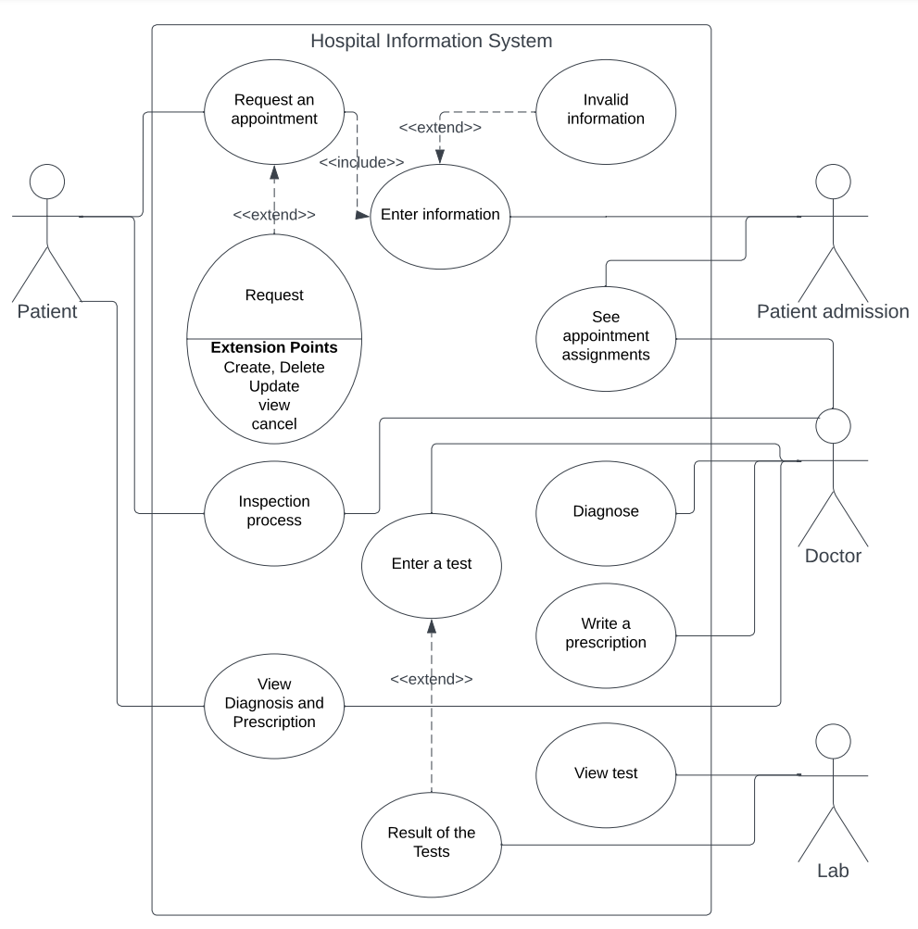

**Brief Descriptions and Step-by-Step Explanations of Each Diagram**

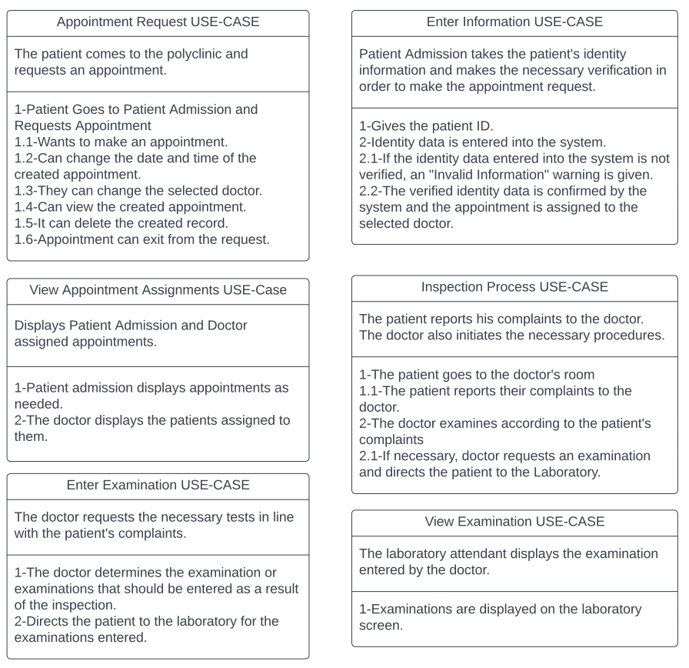

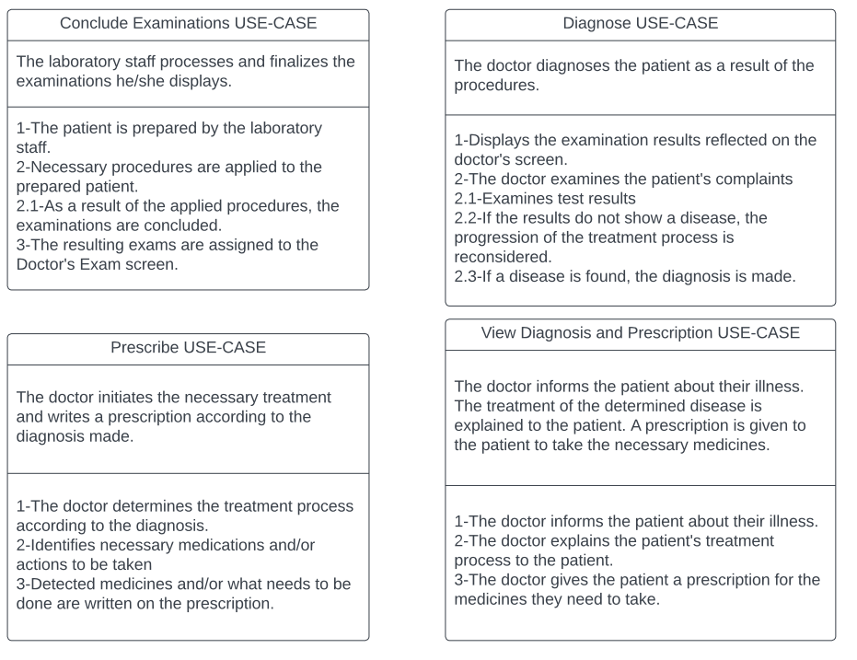

**Functional and Non-Functional Requirements List**

**1-) Functional Requirements**

· Creating an Appointment

· Entering Information

· Updating Appointment

· Deleting an Appointment

· Assigning Patient to the Doctor

· Assigning Test

· Concluding Test Results

· Diagnosis

· Prescribing

**2-) Non-Functional Requirements**

· Appointment Date and Time

· Selecting the Doctor

· Patient's Identity Information

· Examination Process

· Content of the Test Entered

· Result of the Test

· Content of the Diagnosis

· Content of the Prescription

**Analysis Workflow**

**1-Entity Classes**

metin içeren bir resim

Açıklama otomatik olarak oluşturuldu

**2- Controller Classes**

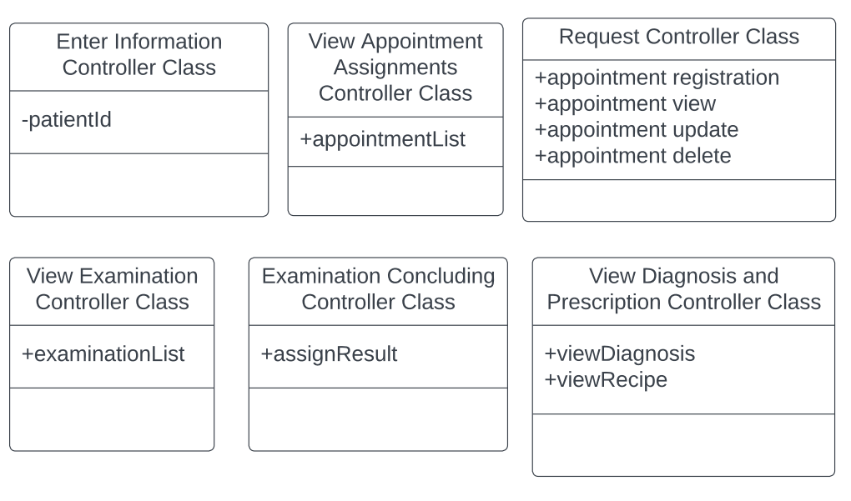

**3- Boundary Classes**

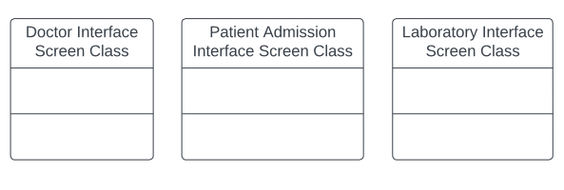

**4-CRC Cards**

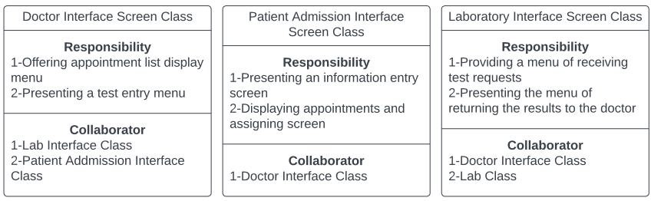

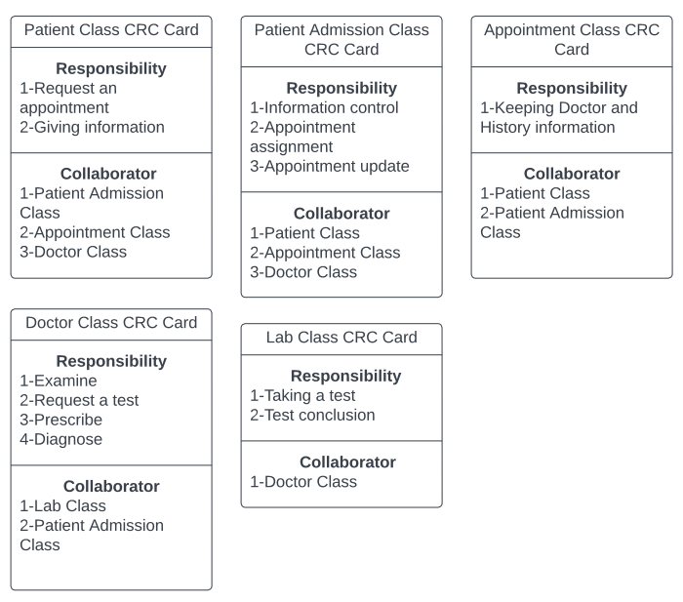

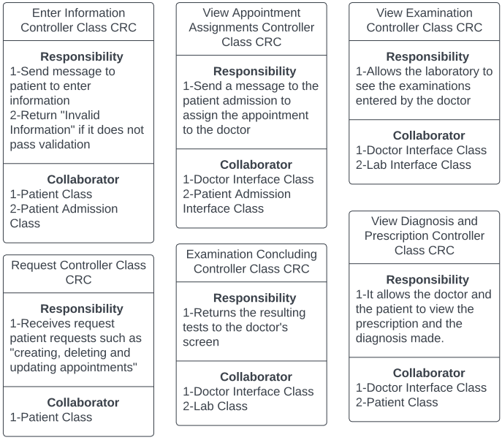

**5- Class Diagram**

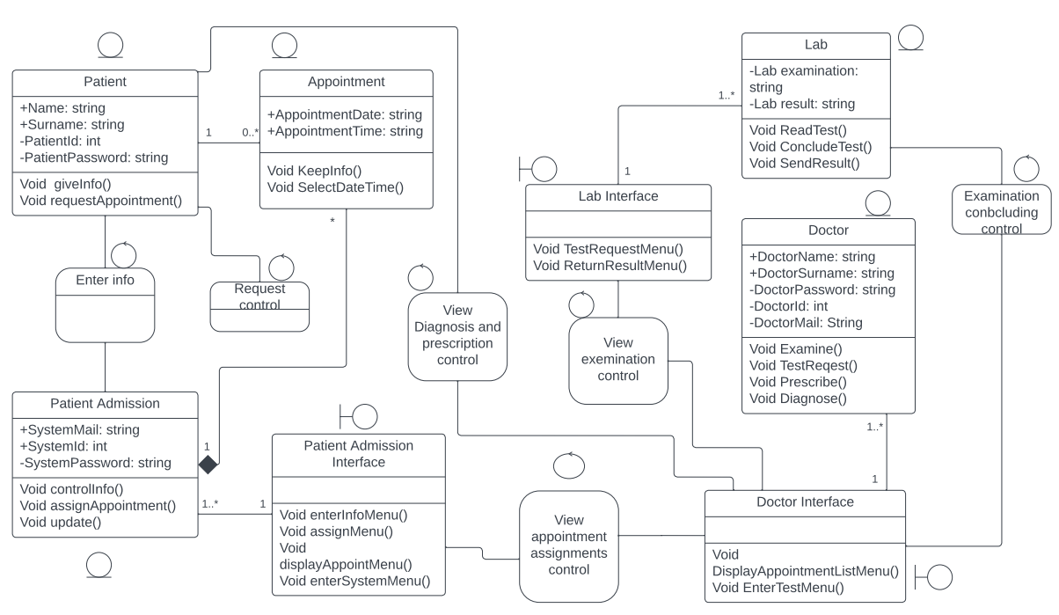

**6- Statechart Diagrams**

**Patient Admission Diagram**

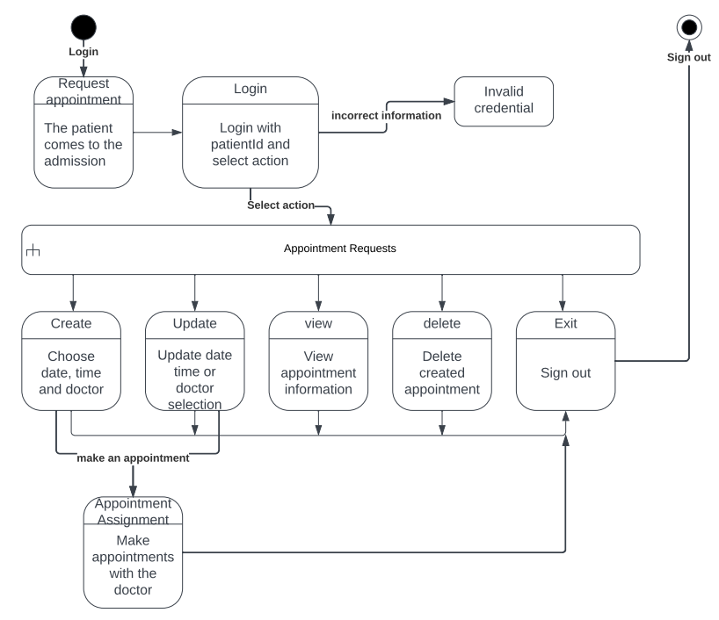

**Lab diagram**

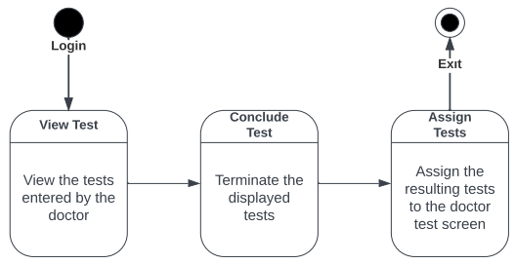

**Doctor Diagram**

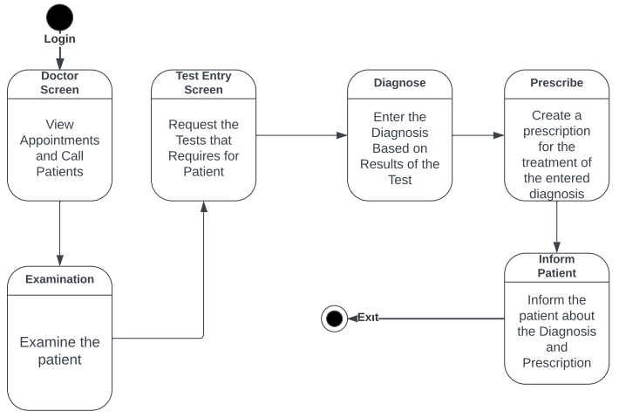

**7- Sequence Diagrams**

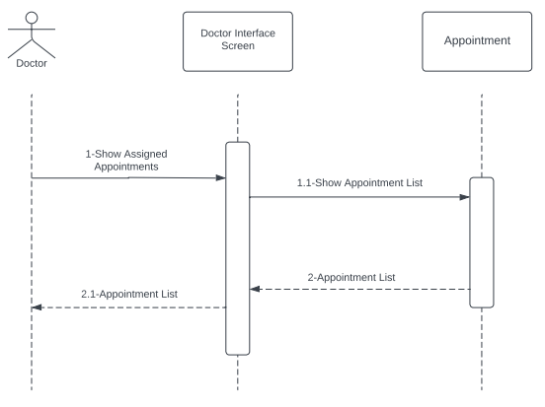

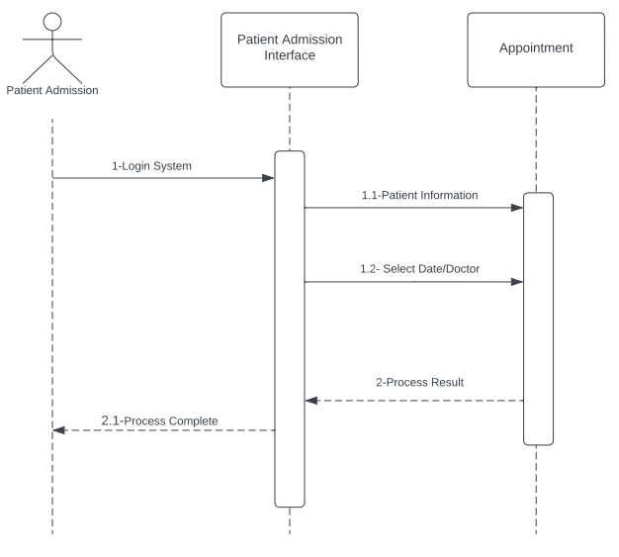

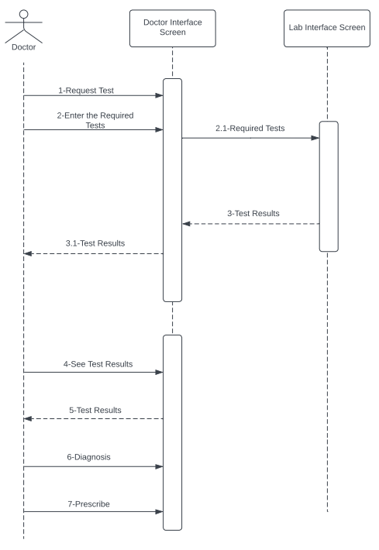

**CREATING SPMP IN IEEE**

**1-Overview**

* 1. **Project Summary**
     1. **Purpose, Scope,Objectives**

The aim of the hospital information system project is to provide a more systematic and practical solution for all processes in the hospital.

* + 1. **Assumptions and Constrains**

The deadline is 30th of December 2022.

The budget constraint must be 200.000 dollars.

* + 1. **Project Deliverables**

The complete product, including user manual, will be delivered 10 weeks after the Project commences.

* + 1. **Schedule and Budget Summary**

1-Requirements Workflow(1 week,4 team member,50.000 dollars)

2-Analysis Workflow(1 week,2 team members,50.000 dollars)

3-Design Workflow(6 days, 2 team members, 50.000 dollars)

4-Implementation Workflow(5 days, 2 team members,30.000 dollars)

5-Testing Workflow(5 days, 2 team members,20.000 dollars)

The total development time is 4 week, and the total internal cost is 200.000 dollars.

* 1. **Evolution of the Project Management Plan**

All changes in the project management plan must be agreed to by each team members before they are implemented.

**2-Referance Materials**

All artifacts will conform to the company’s programming,documentation, and testing standarts.

**3-Definition and Acronyms**

HIS: Hospital information system.

**4-Project Organization**

**4.1 External Interface**

All the work on this Project will be performed by Elif,Mert,Necmeddin and Ahmet.

**4.2 Internal Structure**

The development team consist of, Elif, Mert, Necmeddin and Ahmet.

**4.3 Roles and Responsibilities**

Necmeddin and Ahmet will performed by design workflow. Elif will implement the class definitions and report artifacts. Mert will construct the artifacts that handle investments and operating expenses. Each team member is responsible for the quality of the artifacts he or she produces.

**5-Managerial Process Plans**

**5.1 Start-up Plan**

**5.1.1 Estimation Plan**

As previously stated, the total development time is estimated to be 4 weeks, and the total internal cost to be 200.000 dollars.

**5.1.2 Staffing Plan**

Elif and Mert are needed for the entire 4 weeks, for the first 2 weeks in only managerial capacity and the second 2 weeks programmer.

Necmeddin and Ahmet are needed for the entire 4 weeks, for the first 2 weeks as systems analysist and designer, and for the second 2 weeks as programmers and testers.

**5.1.3 Resource Acqusition Plan**

All necessary hardware, software and CASE tools for the project are already avaible.

**5.1.4 Project Staff Training Plan**

There was no need for personnel training in this project.

**5.2 Work Plans**

**5.2.1-2 Work Activities and Schedule Allocation**

Week 1:Met with client and determined requirements artifacts.

Week 2: Produced analysis artifact and inspected analysises artifact

Week 3:Produced design artifacts.

Week 4:Implementation and inspection of each class, unit testing and documentation.

**5.2.3 Resource Allocation**

**5.2.4 Budget Allocation**

Requirements Workflow:50.000 dollars

Analysis Workflow:50.000 dollars

Design Workflow:50.000 dollars

Implementation Workflow:30.000 dollars

Test Workflow:20.000 dollars

Total:200.000 dollars

**5.3 Control Plan**

**5.4 Risk Management Plan**

**5.5 Project Close-out Plan**

**6- Technical Process Plans**

**6.1 Process Model**

Unified Process Model

**6.2 Methods, Tools and Techniques**

The workflows int he performed in accordance with the Unified Process.

**6.3 Infrastructre Plan**

**6.4 Product Acceptance Plan**

**7- Supporting Process Plan**

**7.1 Configuration Management Plan**

**7.2 Testing Plan**

**7.3 Documentation Plan**

**7.4-5 Quality Assurance Plan and Reviews and Audits Plan**

**7.6 Problem Resolution Plan**

**7.7 Subcontractor Management Plan**

**7.8 Process Improvement Plan**

**8- Additional Plans**

**8.1 Security**

Each patient can log in with their personal information and password.

**8.2 Training**

**8.3 Maintenance**

Corrective maintenance will be performed by the team at no cost for a period of 12 months.

**IEEE 829-2008 TEST PLAN**

**• Introduction**

1. The accuracy of the patient's login information is tested.
2. Appointment request process control.
3. Testing appointment request functions.
4. Testing whether the exams assigned to the laboratory screen are displayed.
5. Testing whether the resulting examination is displayed on the doctor's screen.
6. Control of the buttons in the system.

**• Test Items**

1. Appointment
2. Test

**• Approach**

1. It is tested whether data transfers are carried out correctly

**• Item Pass/Fail Criteria**

1. If the appointment information is missing or incorrect, the appointment will not be confirmed.
2. Checking that the entered tests are assigned correctly on the laboratory screen.

**• Suspension Criteria And Resumption Requirements**

1. If errors are noticed in the test steps, the test activity is suspended.
2. If the error is corrected and it fits the criteria we want, the test activities are continued.

**• Test Deliverables**

1. Test Plan (this document itself)
2. Test Cases
3. Test Scripts
4. Case/ Error Records
5. Test reports

**• Testing Tasks**

**• Responsibilities**

1. Directing:Elif- Ahmet are responsible for this part.
2. Designing:Mert-Necmeddin are responsible for this part.
3. Preparing:Elif-Necmeddin are responsible for this part.
4. Executing:Mert-Ahmet are responsible for this part.
5. Controlling:Ahmet-Necmeddin are responsible for this part.
6. Analyzing:Elif-Mert are responsible for this part.

**• Schedule**

1. It is checked whether each interface and system fulfills its responsibility.
2. The set time to complete each test task is 2 days.

**Design Workflow**

**8- Information Hiding**

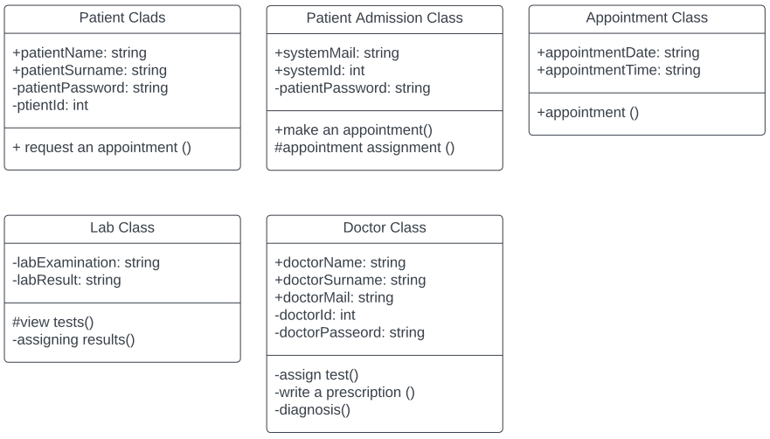

**PSEUDO-CODES OF THE PROJECT**

**Patient Class**

public patient class{

public patient class() //Default Constructure

public string patientName;

public string patientSurname;

private string patientPassword;

private int patientId;

}

**Patient Addmission Class**

public patient addmission class{

public patient admissions class() //Default Constructure

public string systemMail;

public int systemId;

private systemPassword;

public string Login();

public string Exit();

}

**Appointment Class**

public appointment class{

public appointment class() //Default Constructure

public string appointmentDate;

public string appointmentTime;

}

**Lab Class**

private lab class{

private lab class() //Default Constructure

private string labExamination;

private string labResult;

}

**Doctor Class**

public doctor class{

public doctor class() //Deafult Constructure

public string doctorName;

public string doctorSurname;

private string doctorPassword;

private int doctorId;

public string doctorMail;

}

**Enter Information Controller Class**

public enter information controller class{

public enter information controller class() //Definiton Constructure

private string patientId;

}

**View Appointment Assignments Controller Class**

public appointment assignments controller class{

public string appointmentList;

}

**Request Controller Class**

public request controller class**{**

public string appointmentRegistiration;

public string appointmentView()

public void appointmentUpdate()

public string appointmentDelete()

public string appointmentAdd()

public string appointmentCanceled()

}

**View Examination Controller Class**

public examination controller class{

public string examinationList()

}

**Examination Concluding Controller Class**

public examination concluding controller class{

public string assignResult()

}

**View Diagnosis and Prescription Controller Class**

public view diagnosis and prescription controller class{

public string viewDiagnosis()

public string viewReceipe()

}

**Design of Form Interfaces**

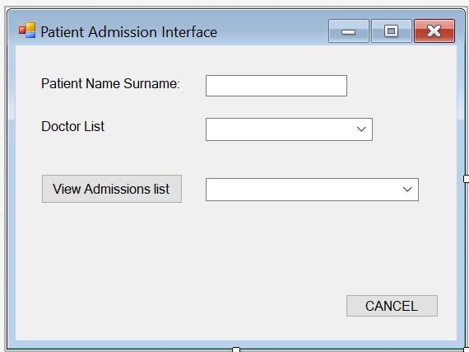

metin içeren bir resim

Açıklama otomatik olarak oluşturuldu

metin içeren bir resim

Açıklama otomatik olarak oluşturuldu